# Diabetes Classification Results using LogisticRegression

## Classification Report:

precision recall f1-score support  
  
 0 0.75 0.73 0.74 146  
 1 0.75 0.77 0.76 154  
  
 accuracy 0.75 300  
 macro avg 0.75 0.75 0.75 300  
weighted avg 0.75 0.75 0.75 300

## ROC AUC Score:

ROC AUC Score (LogisticRegression): 0.8296121686532645

## ROC Curve:

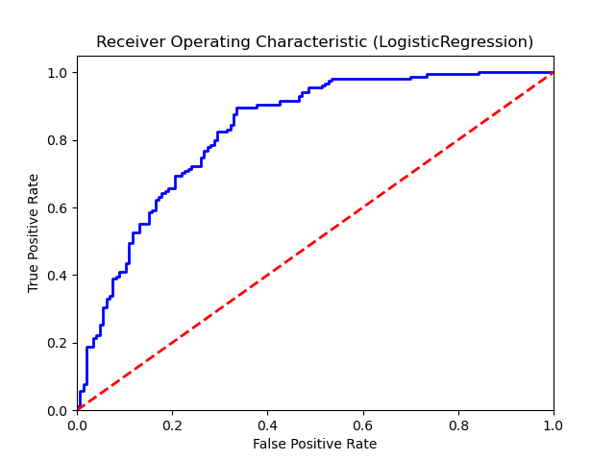

## Confusion Matrix:

True Negatives: 106

False Positives: 40

False Negatives: 35

True Positives: 119

## Confusion Matrix Plot:

